Changes That Need to be made:

1. Adding Additional Summary Page similar to this of Cyrus’s Version:

图形用户界面, 文本, 应用程序

AI 生成的内容可能不正确。

1. Changing Log in Account Number into HKID (Connection with HAGO)
2. Background color for better visualization
3. Additional Voice adjustment for reading questions out loud, explanation of levels and instructions of tools used. (提前录好音频文件，开发的APP的时候，点击图标或者文字播放响应的音频)
4. Changing Wording Size for better visualization
5. Actual Date for filling in each questionnaire and the choice of patient for keeping track of records
6. More accurately of differentiation of scoring level, for each level different actions can be provided on the result report. Example: 0 to 1 level report suggests user do not need to come to the hospital but can have their consultation done via telecare. 3 to 4 level reports suggest for which patients should be advised to seek medical intervention.
7. Comic and animated pictures can be added for patients to feel better and for their preferences.
8. Number of function and choices added for each page and if some pages can be combined.

Examples for Level of symptoms of

**Vomiting in the Past 3 Days**

* Score Level 0 (Not at all): No vomiting occurred at all in the past 3 days.
* Score Level 1 (Seldom): Vomited once in the past 3 days.
* Score Level 2 (Sometimes): Vomited 2-3 times in the past 3 days.
* Score Level 3 (Often): Vomited 4-5 times in the past 3 days.
* Score Level 4 (Always): Vomited every day, totaling more than 5 times in the past 3 days.

**Poor Appetite in the Past 3 Days**

* **Score Level 0 (Not at all)**: No noticeable decrease in appetite; ate normally every day.
* **Score Level 1 (Seldom)**: Experienced poor appetite on one day in the past 3 days.
* **Score Level 2 (Sometimes)**: Had a poor appetite on 2 days in the past 3 days.
* **Score Level 3 (Often)**: Experienced poor appetite on 3 days in the past 3 days, affecting meal intake significantly.
* **Score Level 4 (Always)**: Had a consistently poor appetite every day, leading to minimal food intake.

**Constipation in the Past 3 Days**

* **Score Level 0 (Not at all)**: No issues with bowel movements; regular and normal.
* **Score Level 1 (Seldom)**: Experienced constipation once in the past 3 days.
* **Score Level 2 (Sometimes)**: Had constipation on 2 days in the past 3 days.
* **Score Level 3 (Often)**: Experienced constipation for 3 days, with difficulty in bowel movements.
* **Score Level 4 (Always)**: Suffered from constipation every day, leading to significant discomfort and irregularity.

Changes or New adjustment for interface (Only traditional Chinese Version changed):

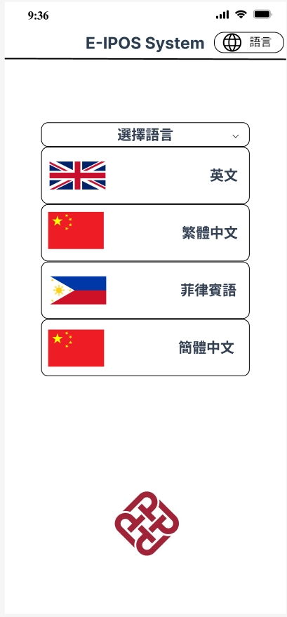

New Language selection page including English, Traditional and simplified Chinese along with Filipino. Additional PolyU logo added to cite project source.

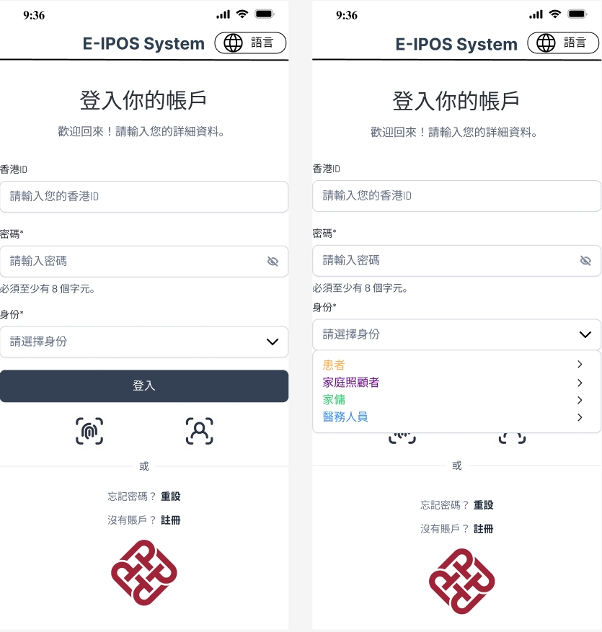

Slightly changed on Language selection for login page. Additional PolyU logo added to cite project source.

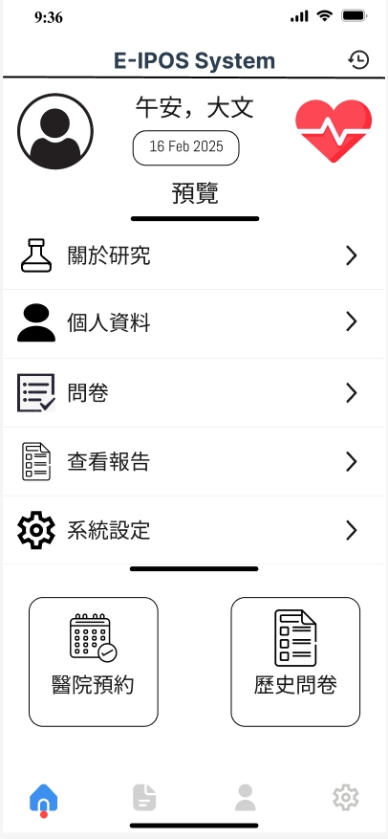

Newly combined home page, adding profile photo, morning/afternoon greeting. Additional function to check hospital appointments and check history questionnaire statics. Added heart logo for better visualization.

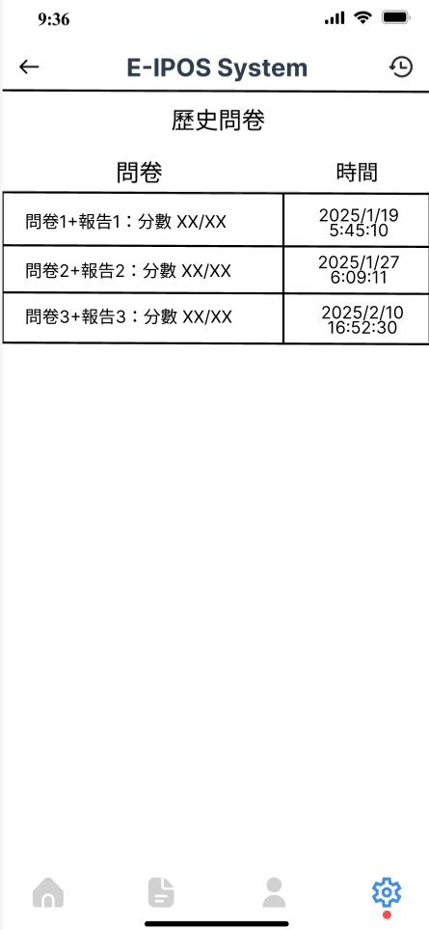

New history questionnaire page along with each score, when user press to enter they can see the history symptoms and score and the health report conducted for them.

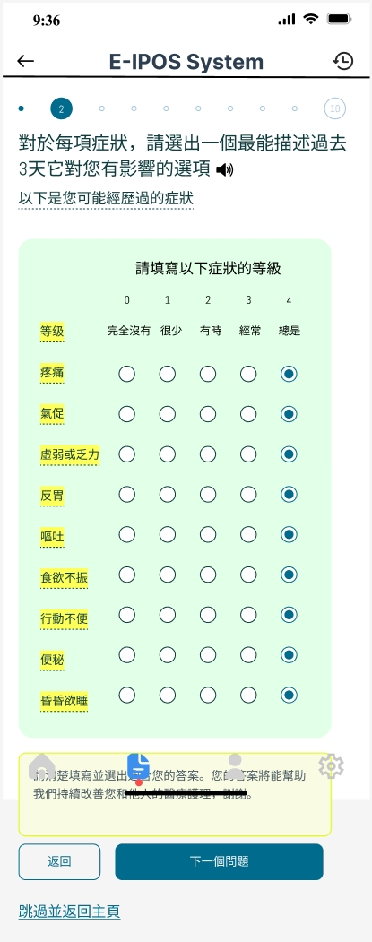

Slightly changed on questionnaire with trumpet logo that user can press and there will be voice out for explanation of question and level description.

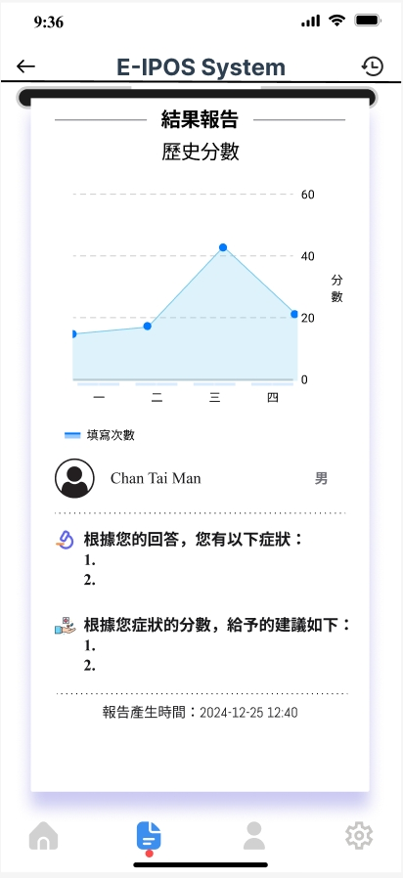

Small change on the score diagram with background color and better visualization.

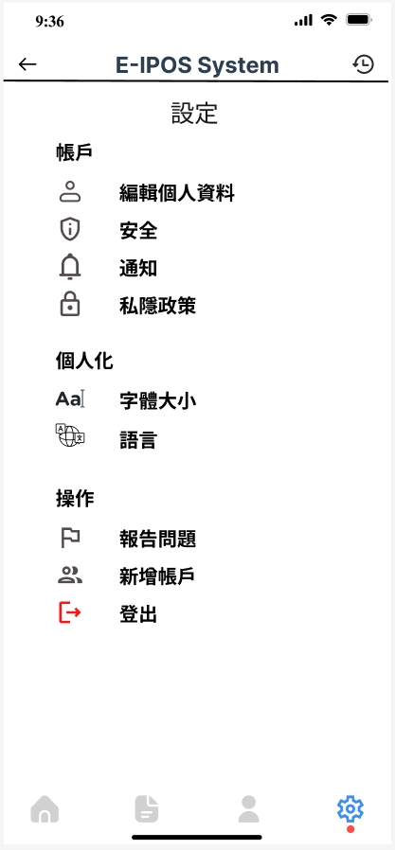

Added red color for log out sign for better visualization.